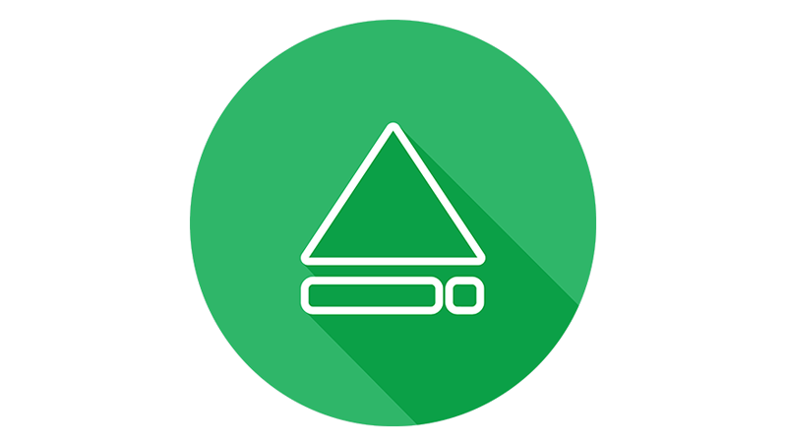
Launch Camp
Info Sheet
________________________________________________________________________
Who?
Middle schoolers going into 6th, 7th and 8th grade (Ages 11-14)
Where?
🌍Beaver Camp- 8884 Buck Point Rd, Lowville, NY 13367
When?
📌August 18-21st 2019, Meet at the church @1:30pm on Sunday the 18th
📌Arrive back to the church @Noon on the Weds the 21st
Why?
Something happens in our students lives when we set time aside for God,
20+ years of testimonies, God moves ever camp and kids get saved!
✅*Guaranteed the best 4 days of your students summer
✅*Fun group games
✅*80 students your kids will become best friends with!

-continued on BACK-

How much does camp cost?

Total: $210
📌$50 downpayment due Weds July 31st
📌remaining due Wednesday August 14th
Fundraising:
📌Launch Car wash: Sunday July 21st ***Be apart!
📌Candy Box sale: get a box from us
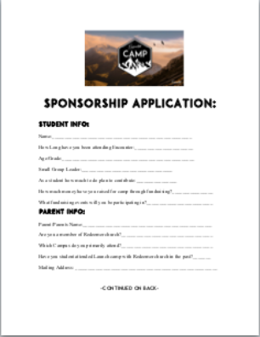
sponsorships:
✅Available where there is need
Grab a sponsorship application form! 👉

-continued-

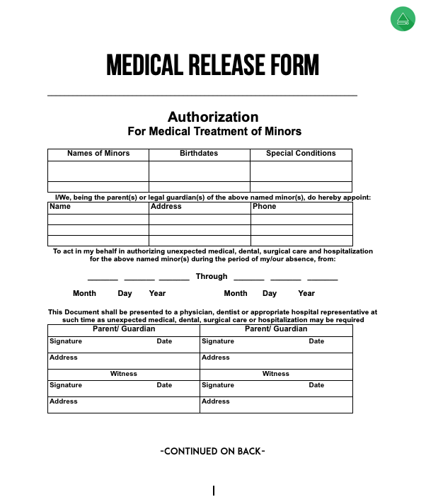
What do I need to go?
- $210 payment
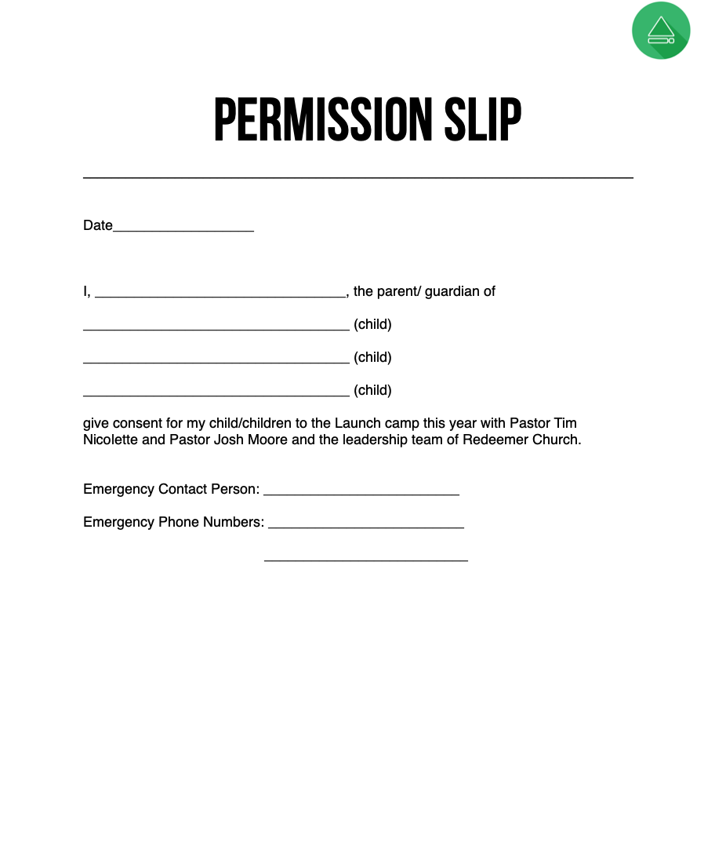
- Permission slip
- Medical Release Form

Packing list?
📌bible/notebook
📌Flashlight
📌clothing for Sunday through Wednesday 📌toiletries (towels)
📌Bedding and a pillow
📌athletic apparel including sneakers 📌bathing suit
📌water bottle
📌Bug spray

